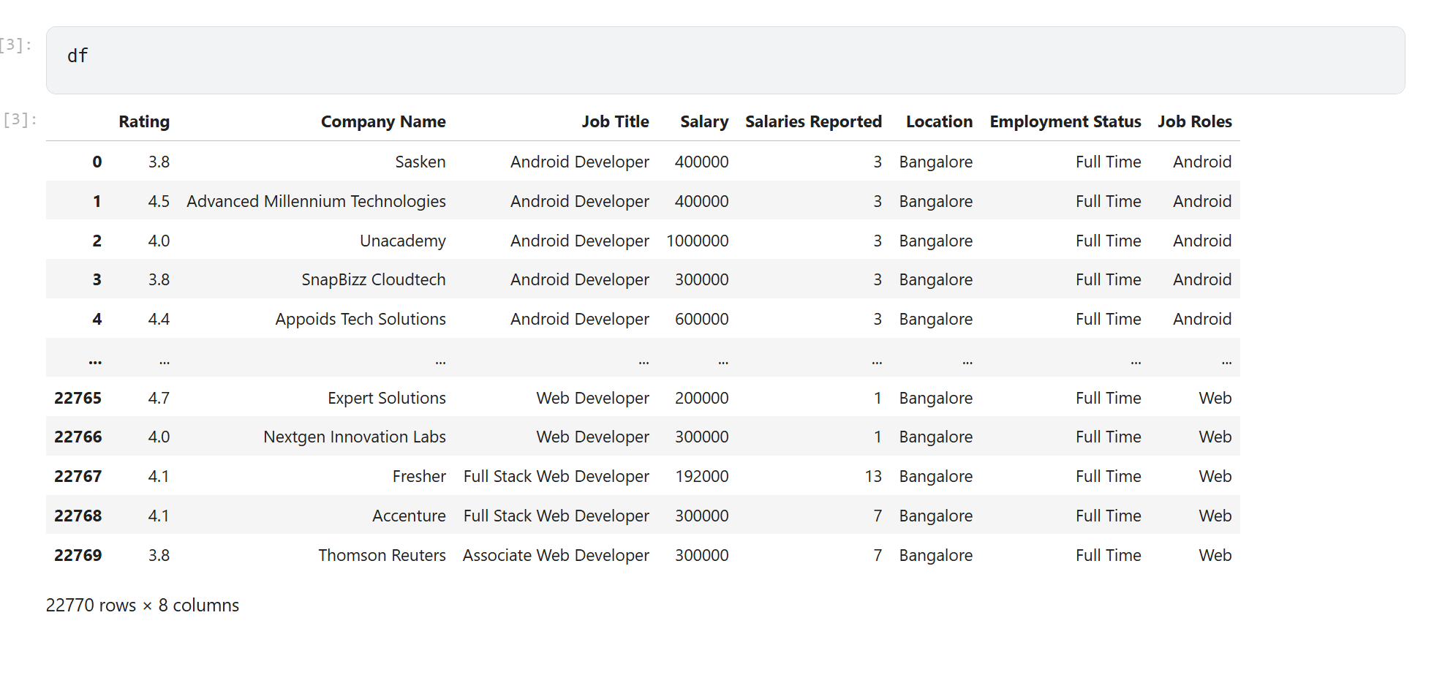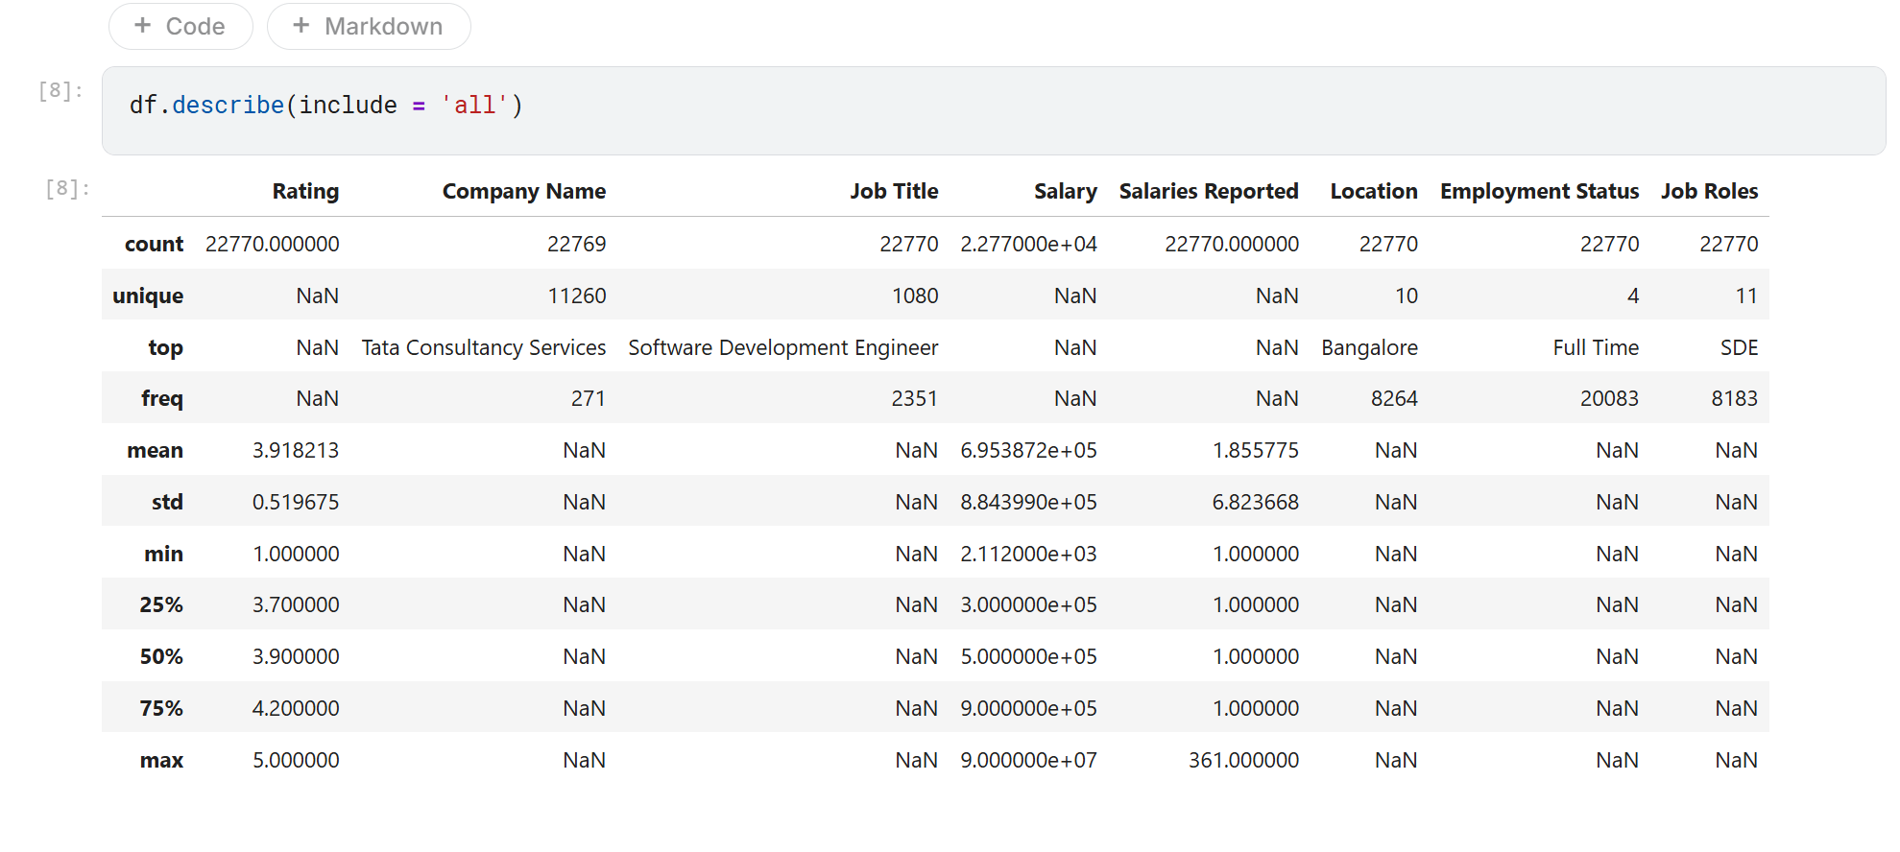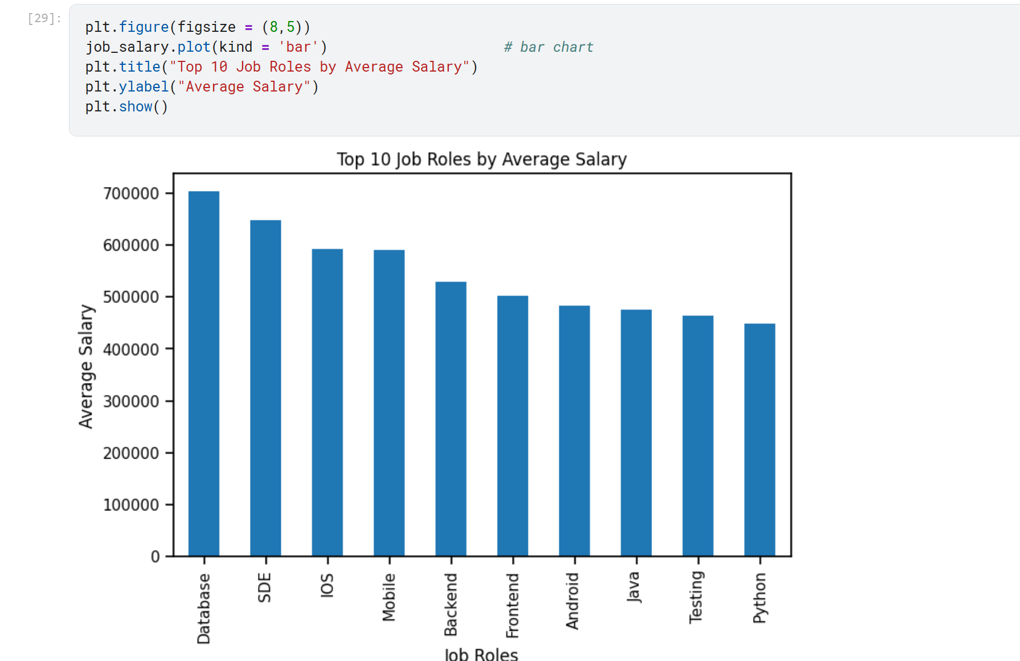
Do langchain application

Sentiment Analysis
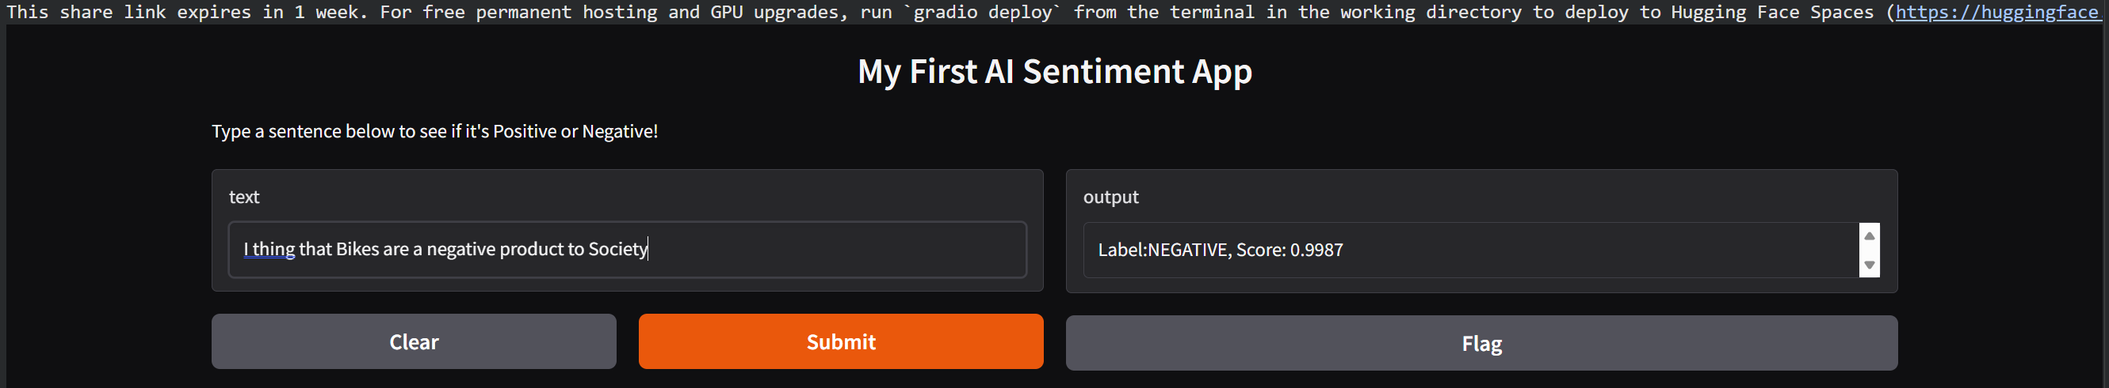
Code
# Step 1: Install the necessary libraries

!pip install -q transformers gradio

# Step 2: Import libraries

from transformers import pipeline

import gradio as gr

# Step 3: Load the sentiment analysis pipeline

# This downloads a pre-trained modelautomatically

classifier =pipeline("sentiment-analysis")

# Step 4: Define a simple function for the app to use

def analyze_text(text):

result = classifier(text)[0]

return f"Label:{result['label']}, Score: {round(result['score'], 4)}"

# Step 5: Create the web interface

demo = gr.Interface(

fn=analyze_text,

inputs="text",

outputs="text",

title="My First AI Sentiment App",
description="Type a sentence below to see if it's Positive or Negative!"

)

# Step 6: Launch the app

demo.launch(share=True)

Fast AI

